QUESTION 1:

Program | Error Message | Cause of Error | Correction Applied
program01.c | 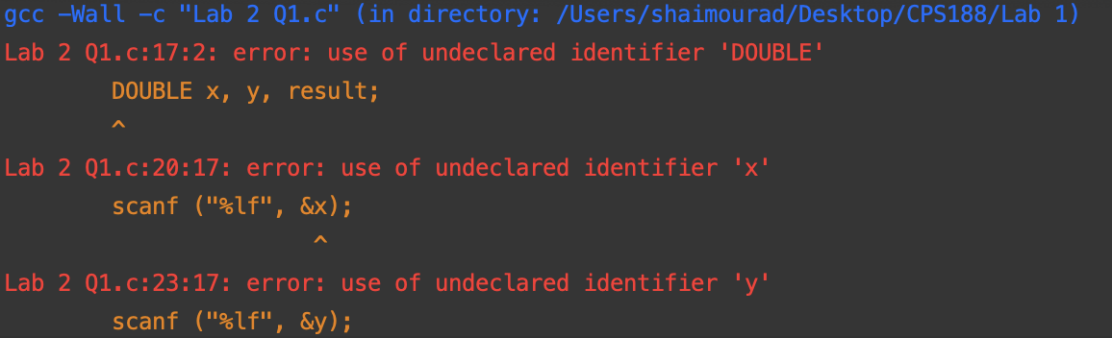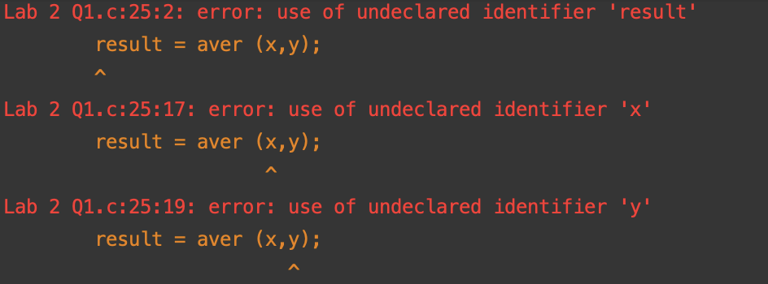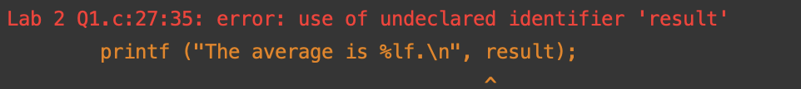 | “double” is in capital letters | double x, y, result;
program02.c | 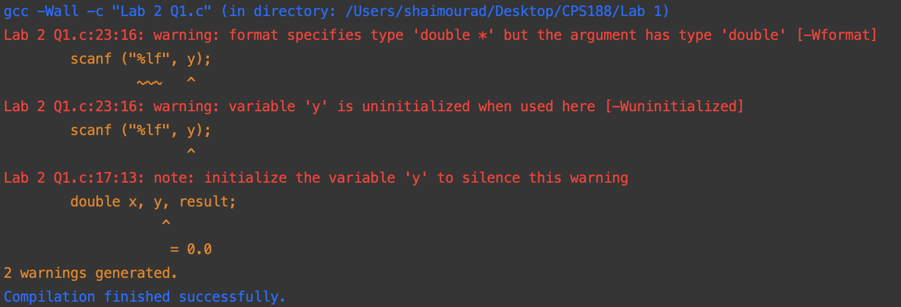 | “&” was not added before “y” value in scanf | scanf ("%lf", &y);
program03.c | 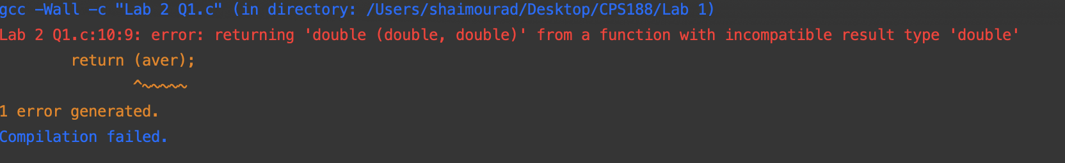 | “return (aver);” is incorrect. It should be written as “return (ave);” | return (ave);
program04.c | 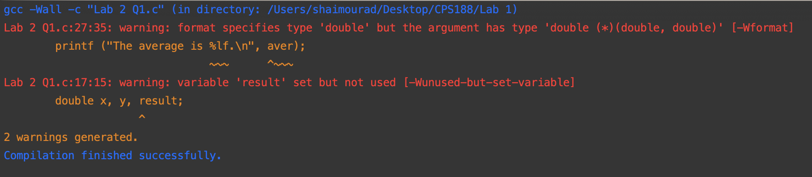 | The wrong function is being used in line 27. “aver” should be replaced with “result” | printf ("The average is %lf.\n", result);
program05.c | 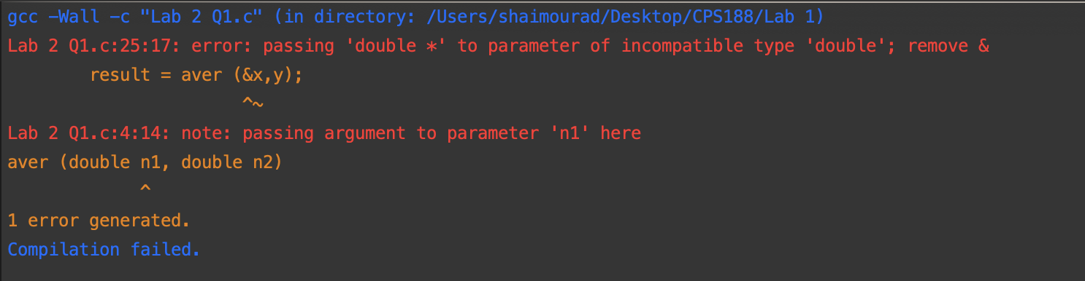 | When “result” is being defined, “x” should not have a “&” before it. | result = aver (x,y);
program06.c | N/A | “n1 + n2” is not in brackets. | ave = (n1 + n2) / 2.0;
program07.c | 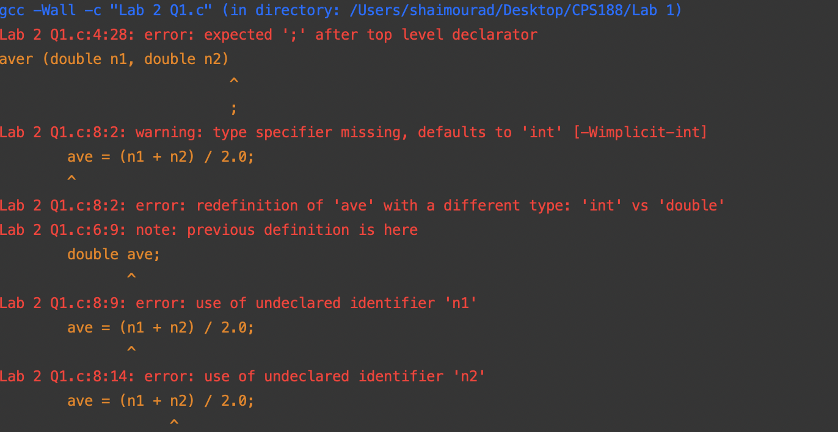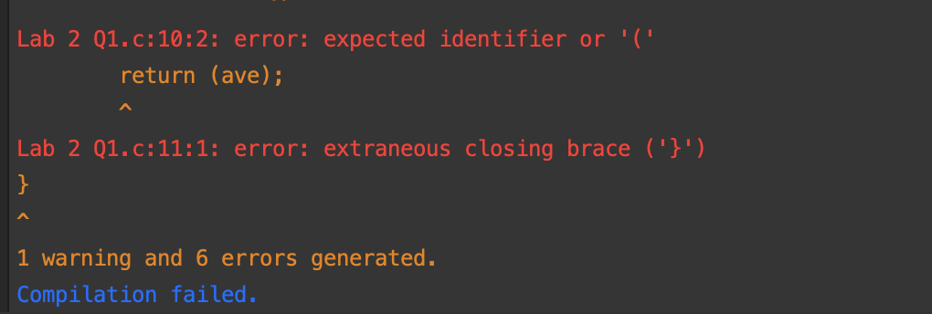 | No open bracket when aver and ave are defined (line 5) | 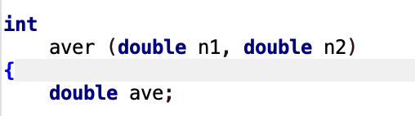
program08.c | 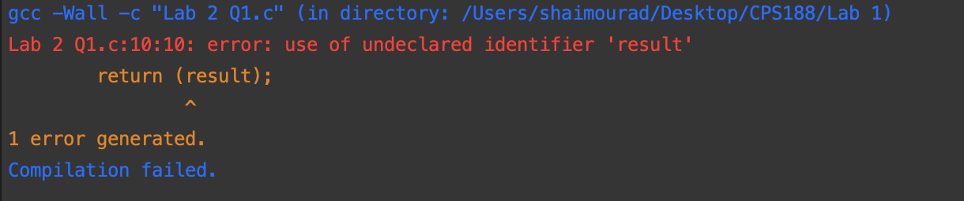 | Returning “result” instead of “ave” in line 10. | return (ave);
program09.c | 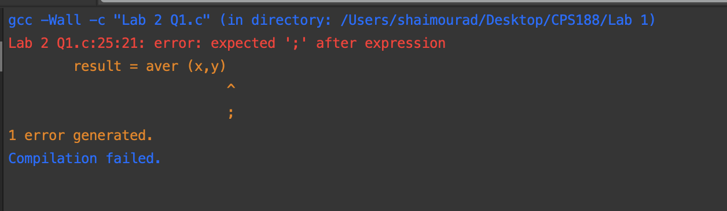 | No semicolon after  “(x, y)”. | result = aver (x,y);
program10.c | 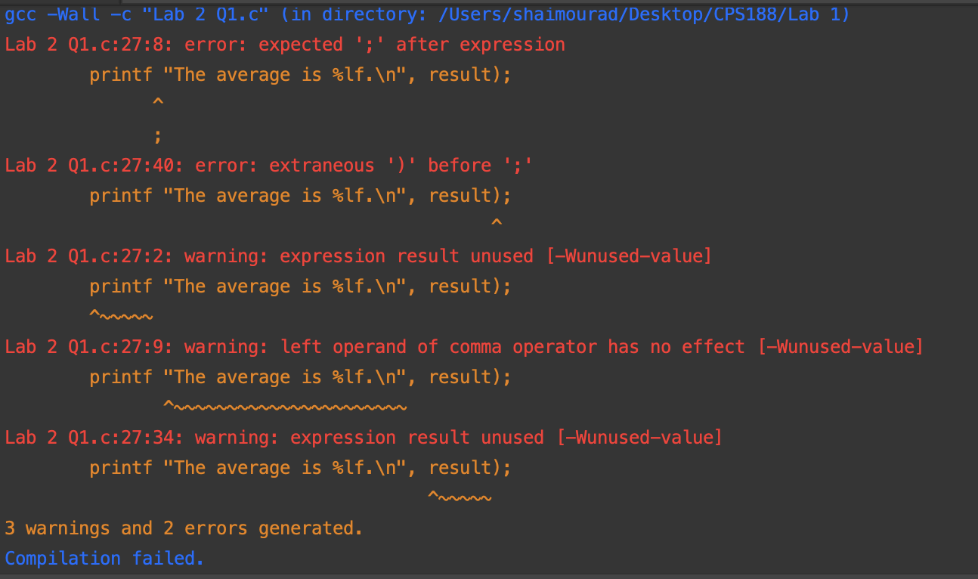 | No bracket before “The | printf ("The average is %lf.\n", result);
program11.c | 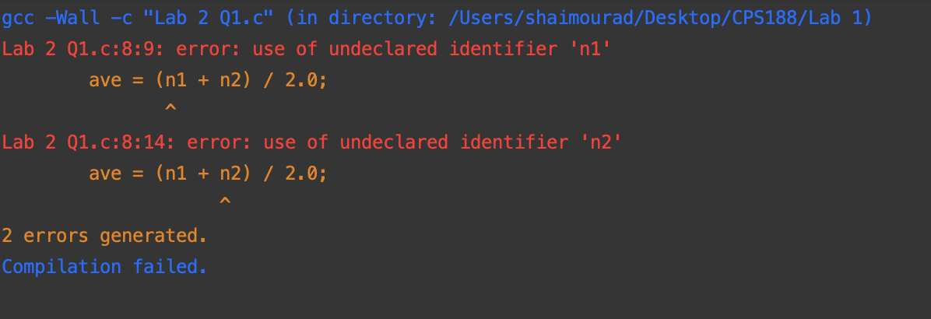 | “x” and “y” are declared instead of “n1” and “n2” on line 4. | aver (double n1, double n2)
program12.c | 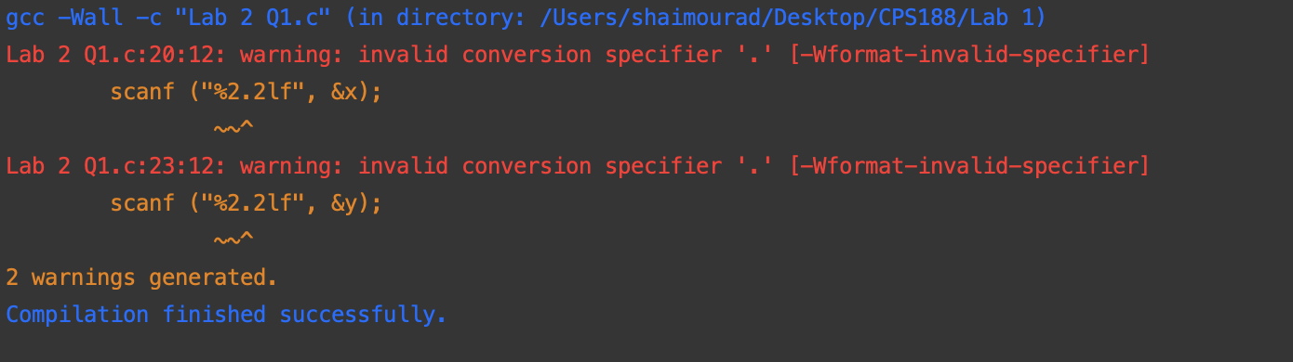 | "%2.2lf” in incorrect format. 2.2 should not be within the statement. | 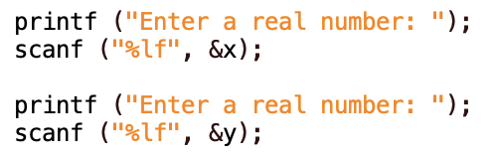
program13.c | 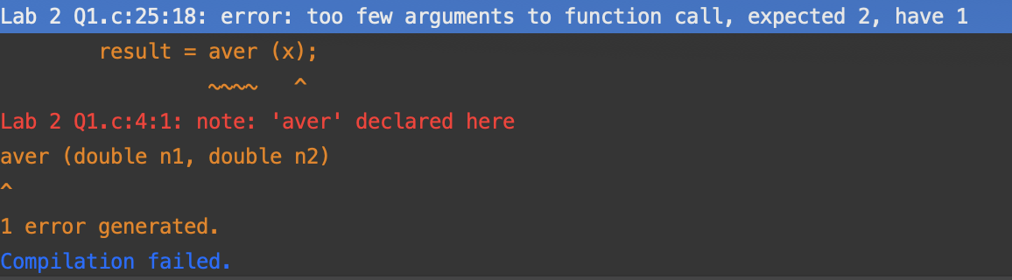 | There are too few arguments in the function “aver”. There should be two rather than one. | Add another argument “y” after “x”  result = aver (x, y);

QUESTION #2:

Algorithm:
- Choose the desired temperature in Celsius
- Convert the celsius temperature to fahrenheit by multiplying by 1.8 and adding 32.
- Use the formula for “a”: 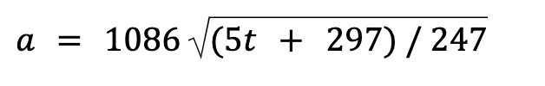to calculate the speed of sound in ft/s → formula:
  - multiply the new temperature by by five
  - add 297
  - divide by 247
  - find the square root of this value
  - multiply by 1086
- Convert the speed to km/h by multiplying by 1.09728.

